EX –11 a) FIFO PAGE REPLACEMENT
NAME : ENIYA B A
CLASS : CSE – A
ROLL NO : 230701085

Program:
#include <stdio.h>
int isPageInFrame(int page, int frame[], int size) {
for (int i = 0; i < size; i++) {
if (frame[i] == page)
return 1;
}
return 0;
}
int main() {
int reference[50], frame[10], ref_len, frame_size;
int i, j, k = 0, faults = 0;
printf("Enter the size of reference string: ");
scanf("%d", &ref_len);
printf("Enter the reference string:\n");
for (i = 0; i < ref_len; i++) {
printf("Enter [%d]: ", i + 1);
scanf("%d", &reference[i]);
}
printf("Enter the page frame size: ");
scanf("%d", &frame_size);

for (i = 0; i < frame_size; i++)
frame[i] = -1; // initialize with -1

printf("\nPage Replacement Steps:\n");
for (i = 0; i < ref_len; i++) {
printf("%d -> ", reference[i]);
if (!isPageInFrame(reference[i], frame, frame_size)) {
frame[k] = reference[i];
k = (k + 1) % frame_size; // FIFO index cycle
faults++;
for (j = 0; j < frame_size; j++) {
if (frame[j] != -1)
printf("%d ", frame[j]);
}
printf("\n");
} else {
printf("No Page Fault\n");
}
}
printf("\nTotal page faults: %d\n", faults);
return 0;
}

OUTPUT :
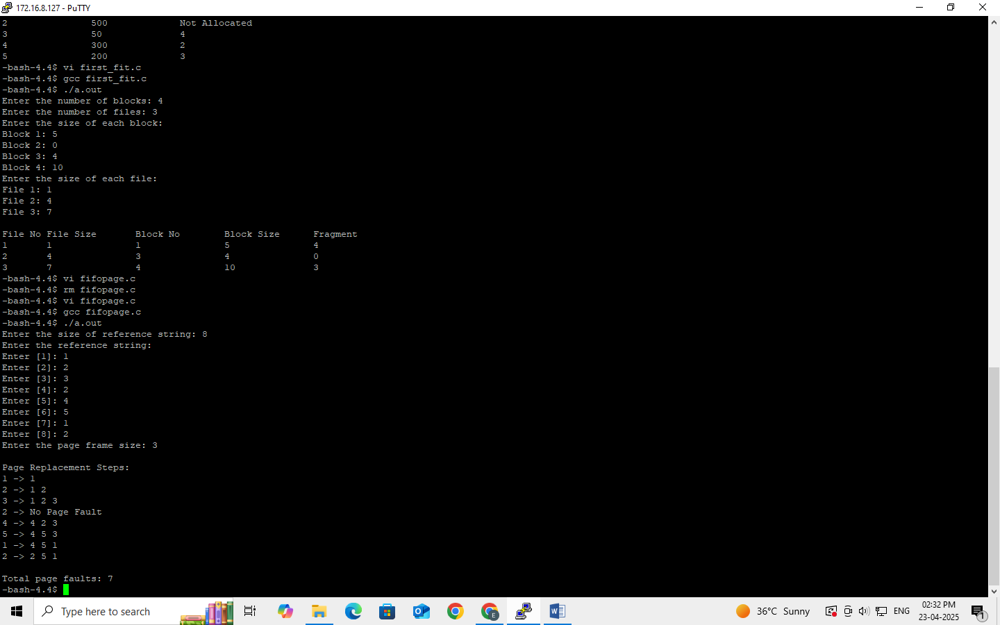

11 b) LRU
Program :
#include <stdio.h>
int findLRU(int time[], int n) {
int i, min = time[0], pos = 0;
for (i = 1; i < n; i++) {
if (time[i] < min) {
min = time[i];
pos = i;
}
}
return pos;
}
int main() {
int frames[10], pages[30], counter[10];
int n, f, i, j, k, pos, faults = 0, time = 0, flag1, flag2;
printf("Enter number of frames: ");
scanf("%d", &f);
printf("Enter number of pages: ");
scanf("%d", &n);
printf("Enter reference string: ");
for (i = 0; i < n; i++) {
scanf("%d", &pages[i]);
}
for (i = 0; i < f; i++) {
frames[i] = -1;
}
printf("\n");
for (i = 0; i < n; i++) {
flag1 = flag2 = 0;
for (j = 0; j < f; j++) {
if (frames[j] == pages[i]) {
time++;
counter[j] = time;
flag1 = flag2 = 1;
break;
}
}
if (flag1 == 0) {
for (j = 0; j < f; j++) {
if (frames[j] == -1) {
time++;
faults++;
frames[j] = pages[i];
counter[j] = time;
flag2 = 1;
break;
}
}
}
if (flag2 == 0) {
pos = findLRU(counter, f);
time++;
faults++;
frames[pos] = pages[i];
counter[pos] = time;
}
for (j = 0; j < f; j++) {
if (frames[j] != -1)
printf("%d ", frames[j]);
else
printf("-1 ");
}
printf("\n");
}
printf("\nTotal Page Faults = %d\n", faults);
return 0;
}
OUTPUT :
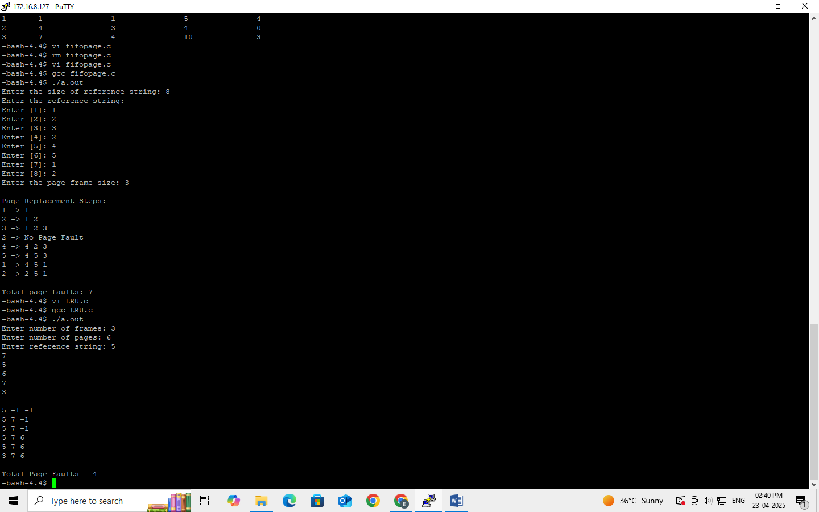

11 c) Optimal
Program :
#include <stdio.h>

int findOptimal(int pages[], int frames[], int n, int f, int current) {
int farthest = current, pos = -1;

for (int i = 0; i < f; i++) {
int j;
for (j = current + 1; j < n; j++) {
if (frames[i] == pages[j]) {
if (j > farthest) {
farthest = j;
pos = i;
}
break;
}
}
if (j == n) {
return i; // If the page is not found in the future reference string
}
}
return pos;
}

int main() {
int frames[10], pages[30];
int n, f, pageFaults = 0;

printf("Enter number of frames: ");
scanf("%d", &f);

printf("Enter number of pages: ");
scanf("%d", &n);

printf("Enter reference string: ");
for (int i = 0; i < n; i++) {
scanf("%d", &pages[i]);
}

for (int i = 0; i < f; i++) {
frames[i] = -1; // Initialize frames to -1 (empty)
}

printf("\n");

for (int i = 0; i < n; i++) {
int found = 0;

// Check if the page is already in memory
for (int j = 0; j < f; j++) {
if (frames[j] == pages[i]) {
found = 1;
break;
}
}

if (!found) {
// If memory is full, find the optimal page to replace
int replacePos = -1;

for (int j = 0; j < f; j++) {
if (frames[j] == -1) {
frames[j] = pages[i];
pageFaults++;
found = 1;
break;
}
}

// If no empty space, apply the optimal page replacement strategy
if (!found) {
replacePos = findOptimal(pages, frames, n, f, i);
frames[replacePos] = pages[i];
pageFaults++;
}
}

// Display the current state of memory (frames)
for (int j = 0; j < f; j++) {
if (frames[j] != -1)
printf("%d ", frames[j]);
else
printf("-1 ");
}
printf("\n");
}

printf("\nTotal Page Faults = %d\n", pageFaults);
return 0;
}

OUTPUT :

